
UHS: Medication Reconciliation Process
Home Med List – Nurse and Patient
Go to: Home Med List Tab.
This tab should list the results of the Med Query that is automatically processed upon patient admission into HCS. This query searches all pharmacies within the fifty United States, going back for 180 days. All prescribed meds (thus not OTC) dispensed should be listed. The only exception will be those dispensed via the VA (Veterans Administration).
Each med should have an ‘MQ’ to the left, indicating the med listed is a result of the Med Query.
The patient’s admitting Nurse should review the list with the patient. The Nurse will then update each med’s status. This will be shown to either reflect that the patient no longer takes the med via a status of ‘IM’ (inactivated med, which will also be struck through) or that the patient does currently take the med via a status of ‘CV’ (Clinician Verified).
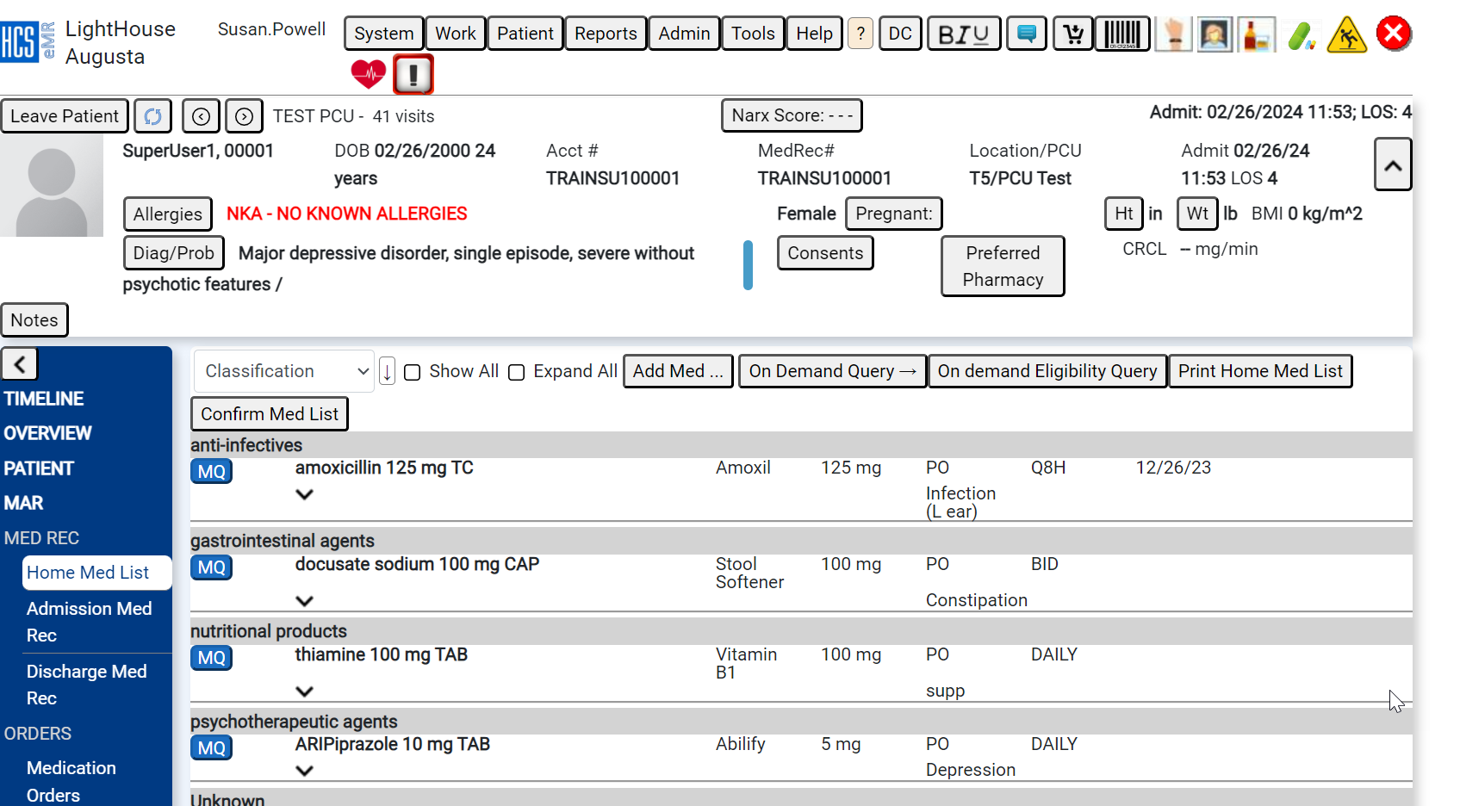
To inactivate a med, click on “MQ” select Inactivate. When you do this, the “MQ” will then change to “IM” (Inactive Med).
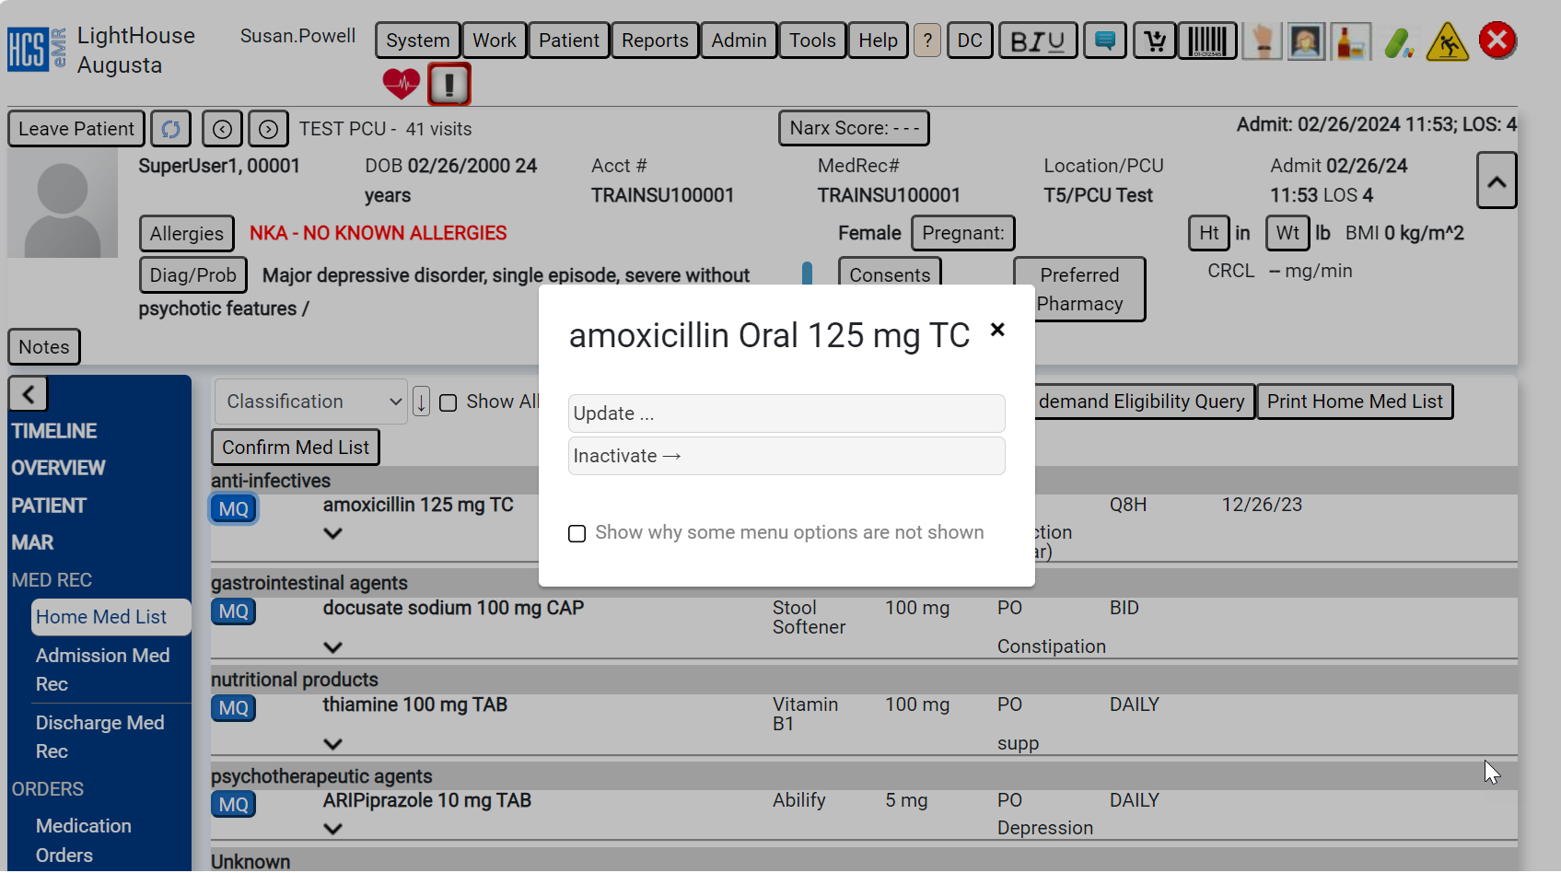

If the patient says they do take one of the meds on the list, double click on the med and if there is nothing filled in the dose, route, frequency, and indication column, you will need to put that information before saving. When saving, it will then change from “MQ” to “CV” (Clinician Verified).
Once the MQ list is addressed, the admitting Nurse should then ask the patient if they currently take any meds that were not listed. The nurse will add these to the list via the Add button at the bottom of the Home Med List tab.

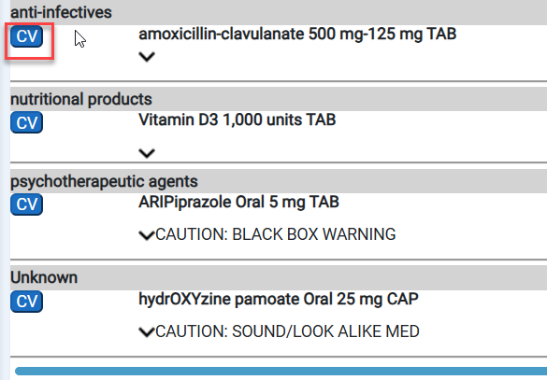

Before leaving this page, the Nurse should ask the patient which pharmacy they use to have their prescriptions filled. Then, the Nurse should click on the Preferred Pharmacy button in order to use the Pharmacy Map Search functionality to record the patient’s preference. (This will prevent delays when the Provider is attempting to e-Prescribe at discharge.)
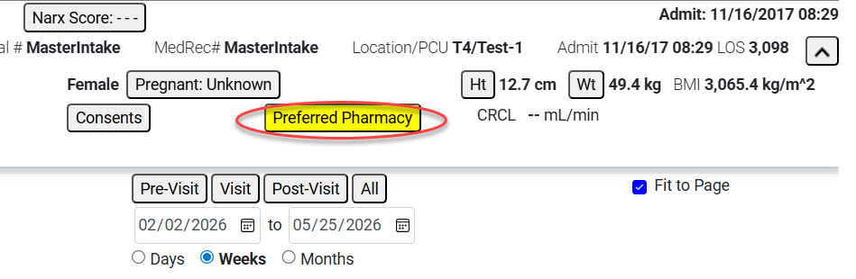

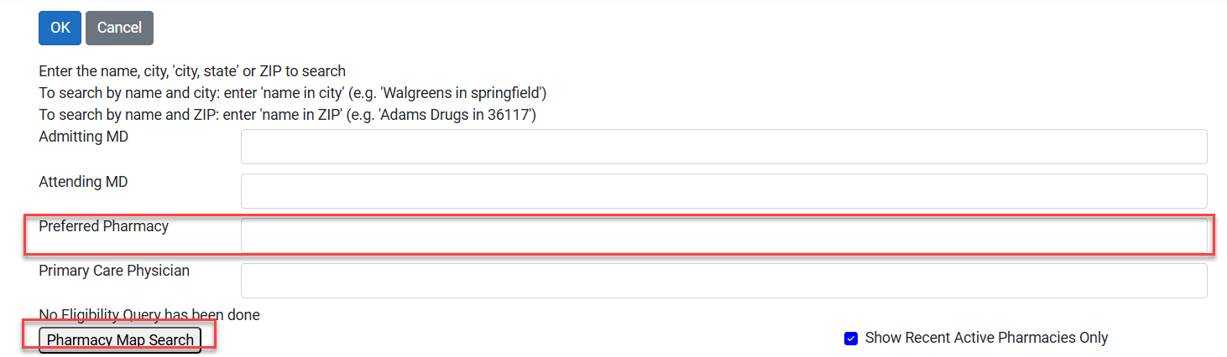
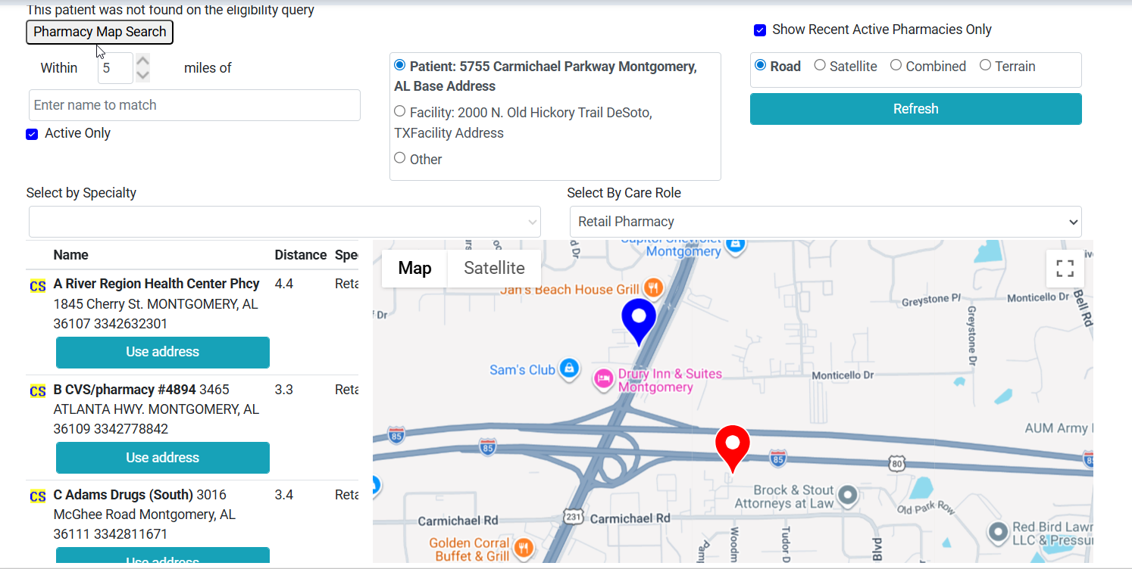
Select one of the pharmacies from the list shown and click ok.
Finally, the admitting Nurse will then click the ‘Confirm Med List’ button at the bottom of the Home Med List tab.
This confirmation moves all current meds being taken by the patient over to the next tab to the right: Admission Med Rec.

Admission Med Rec – Provider or Nurse on phone with Provider
Once the Nurse has completed the Home Med List (all meds have either IM or CV status), Go to:
Admission Med Rec tab.
Each med will have 2 checkboxes available: Continue or Discontinue. Each med MUST have one of these boxes checked.
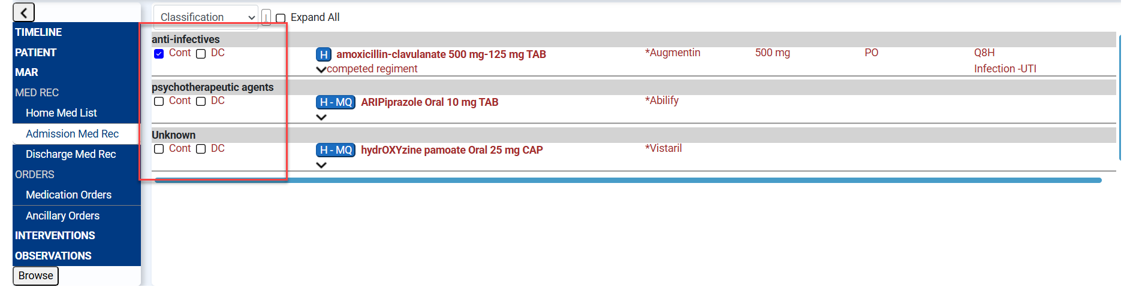

During work hours, 8 a.m. - 5 p.m. (Monday - Friday)
- This tab will be completed by the Attending Provider. Once each med is checked Continue or Discontinue, the Provider will click the red ‘e-Sign and Send to Pharmacy’ button at the bottom of the tab. It will turn green once they’re sent. They then appear on the Medication Orders tab, where all Admission orders (individual, protocol, favorites, etc.) should be entered. NO MEDS SHOULD BE ADDED ON ADMISSION MED REC TAB.
*IF the Attending has left the building during work hours, the Nurse will call the attending and walk through this tab together while the Attending remains on the phone (in case any alerts appear).
After work hours, the Nurse will have this tab addressed by the on-call provider while remaining on the phone.
- The on-call Provider should remain on the phone while the Nurse updates each med with a check in the Continue or Stop box in case any alerts appear (as answering these is outside the scope of a Nurse’s license and not addressing them will prevent continuing).
After all meds have been addressed via the on-call provider, the Nurse will hit the ‘Send to Pharmacy’ button at the bottom of the tab.
If the nurse is completing this, they will get a popup message, “Please confirm that you have Read Back and Verified this order. Click CONTINUE if you have or Click CANCEL if you have NOT.
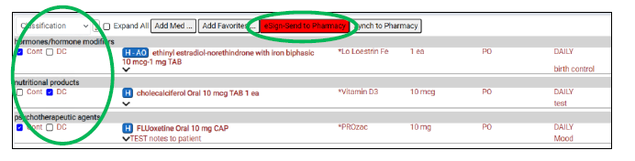

UHS: Medication Reconciliation Process at Discharge
Background
Providers must complete the Discharge Medication Reconciliation process in HCS at the time of discharge and prior to e-prescribing discharge medications. This process must be completed prior to printing the Patient Discharge Medication document to ensure that the patient receives an accurate list of their medications.

HCS Clinicals can send E-prescriptions to outside pharmacy, but the medication order must meet the following criteria:
• The patient DOES have a preferred pharmacy set up.
• The RX check box is selected (checked) for the medication.
Function:
- Provides an electronic orders area for provider to:
*Review active meds and home medications not continued in the hospital.
*Complete the Discharge Med Rec and Patient education discharge information. Provider is required to address EVERY medication listed.
- Provides availability to e-Prescribing directly to outside pharmacy.
*Preferred pharmacy may be updated or changed here

- Nurse may take Telephone orders to stop or continue, as per Prescribers Direction
*Nurse CANNOT mark med as “Rx” or ePrescribe
  - Upon Provider completion, you can Click the Print Patient Summary and Education Sheets button.
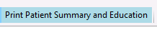

Steps to complete discharge medication reconciliation:
- Navigate to the patient profile, click the Discharge Med Rec to see a merged list of home medications and inpatient medications.
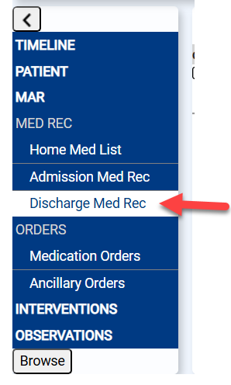

- Review if there is a Preferred Pharmacy listed at the top Right of the patient banner.

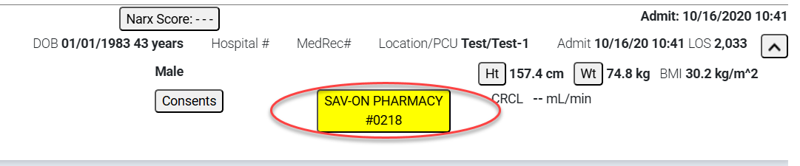
  - If no pharmacy is listed
  - Select Preferred Pharmacy and click update.
  - Select the empty box following Preferred Pharmacy.
  - In the ‘Preferred Pharmacy’ field, begin by typing in the zip code of the pharmacy desired or type the first few letters of the city of the pharmacy’s location. (See directions at the top of the window.)
  - An alternate search for a pharmacy is the pharmacy map search, which functions just like Google Maps.




Colors codes for Medications:
I - Inpatient Medication - in Green
H - Home Medications - in Red
B - Both Inpatient and Home medication - in Blue
Black font indicates added medications
Purple medications indicate the home and inpatient medications are similar.
Ex: Medications from the same or similar class and require review

- Check the appropriate check box for each medication.
  - Ensure the Show all and expand all boxes are checked, showing all other medications that may have been discontinued.
  - Select the Cont box to let the patient know they should continue taking the medication after discharge.
  - Select the DC checkbox for any medications the patient should not continue taking after discharge.
  - Select the Rx check box for any medication that needs a new prescription. This will auto populate the Cont checkbox. The e-Sign and SEND button will change to green if any Rx checkbox is checked.
  - Add additional medications if applicable.
- When all medications have been addressed and all new medications have been added, select the e-sign and SEND button.

- Select the Print Patient Summary and Education button if needed. See Generate Discharge Summary and Education for details.

Generate E-Prescription & Adding a New E-Prescription
You may need to add an e-prescription for a medication that the patient did not take at the hospital or at home.
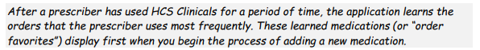
- To complete discharge reconciliation of inpatient and home medications, select the DC checkbox for medications that should NOT be continued and select the Cont checkbox for medications that SHOULD be continued but for which a prescription will NOT be generated. To generate a prescription for an existing inpatient or home medication, select the Rx check box, which will automatically check the continue box.

- Once the Rx checkbox has been selected for an order, quantity, days’ supply, refill, and sig information may be populated automatically based on facility-configurable setting. Review information then update to make changes if needed.

3. Select the e-sign and Send button.
- The Rx Send Summary window is displayed, allowing the user to complete a final review before sending the prescriptions. Information in this window is sent to the preferred pharmacy. Select the Send e-Rxs button to complete the process.

- The status of the order is displayed in the far right of the order row. Select the refresh patient button. Within 1 minute the status should change from Not sent to Sent, then with another refresh will display Accepted, Verified, or Rejected (with error information).

- Statuses of Verified or Accepted indicate the retail pharmacy received the order. Any other status, including the order remaining with a Not Sent or any other status that is not Verified or Accepted means the order was not received. These statuses should be investigated with a high priority.

Adding a New E-Prescription
Steps
- Access a patient. Select the Discharge Med Rec link for inpatients or the Outpatient Med Orders link for Outpatients.

- Select the Add Med button.

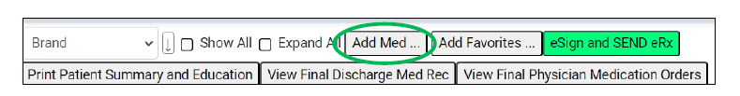

- Select the order sentence from the list of learned favorites or type the first few letters of the brand or generic name of the medication then input required fields. The Notes to O/P Pharmacy field is used for free text to be sent to the retail pharmacy.

- Select the Okay button.
- Select the e-Sign and SEND button to send one or more prescriptions.
- The Rx Send Summary window is displayed, allowing the user to complete a final review before sending the prescriptions. Information in this window is sent to the preferred pharmacy. Select the Send e-Rxs button to complete the process.

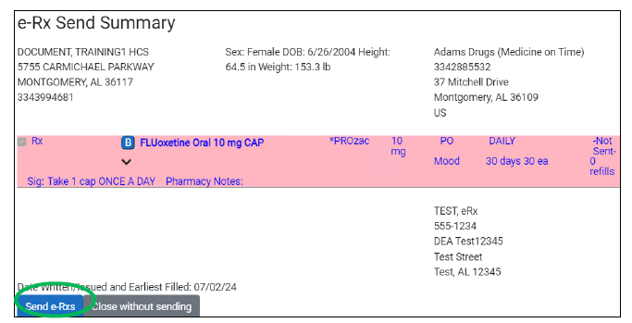

Discharge Summary and Education
- Select the button to the left of the medication name then select Update.

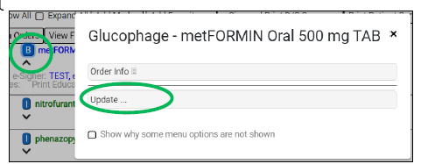
- Check the box for Education then select the Okay button.

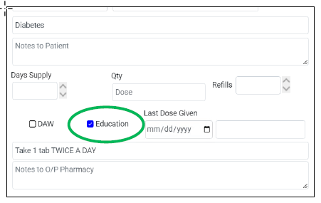
- Select the e-sign and Send button. Documents print automatically. To see the documents before printing, select the Patient Summary and Education button.

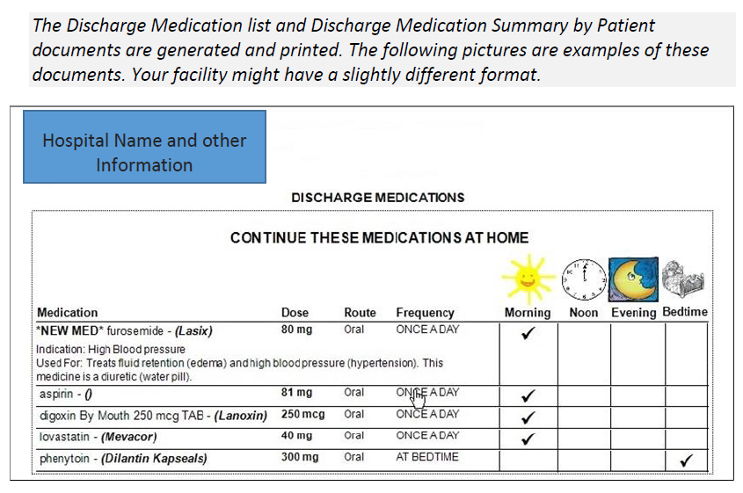

Insurance Status e-prescribing Key

If the patient’s insurance information was found on the eligibility query, when a provider adds a prescription for the patient, the patient’s insurance formulary information may display when the provider selects the Item field on the Add Order window.
NonFormulary – The medication is not on the patient’s insurance formulary list.
NonFormularyWithCoverage – The medication is not on the patient’s insurance formulary list and has coverage restrictions.
NonReimbursableFormularyStatus – The medication is not on the patient’s insurance formulary list and will not be reimbursed at all.
NonReimbursableFormularyStatusWithCoverage – The medication is not on the patient’s insurance formulary list, will not be reimbursed at all, and has coverage restrictions.

OnFormulary – The medication is on the patient’s insurance formulary list.

OnFormularyWithCoverage – The medication is on the patient’s insurance formulary list and has coverage restrictions.

PreferredFormularyStatus - The medication is on the patient’s insurance formulary list and is preferred. A “+” sign followed by a number in the image represents the amount of preference; higher numbers signify higher preference.
PreferredFormularyStatusWithCoverage - The medication is on the patient’s insurance formulary list, is preferred, and has coverage restrictions.

UnknownFormularyStatus – The insurance formulary status is unknown (probably because the patient’s insurance is unknown).
UnknownFormularyStatusWithCoverage – The insurance formulary status is unknown, and medication has coverage restrictions.


After the prescription is sent, the insurance statuses disappear and are replaced by e-prescription statuses. The following table lists the possible e-prescription status values.
